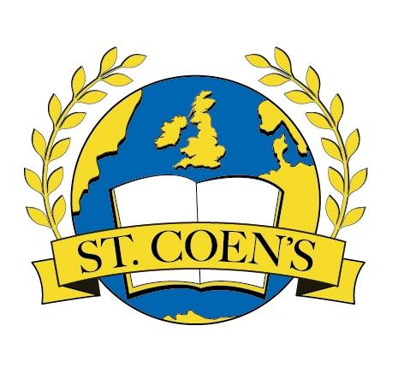
Physical Education Plan

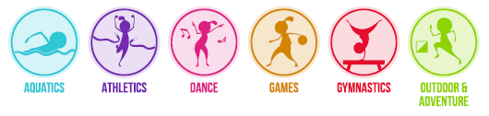

Table of Contents
Introductory Statement 03
Rationale 03
Vision 03
Aims 04
Continuity and Progression 08
Approaches and Methodologies 09
Multi-class teaching 11
Differentiation 13
Assessment and Record Keeping 15
Equality of Participation and Access 16
Linkage and Integration 16
Organisational Planning 17
Whole School PE Plan Year 1 18
Whole School PE Plan Year 2 19
Organisational Tips for PE 20
Code of Ethics 21
PE Equipment 22
ICT 22
Health and Safety Considerations 23
Staff Development 24
Active School Week 24
After School Activities 24
Parental Involvement 24
Community Links 25
Success Criteria 25
Review 25
Inspectorate Ratification and Communication 25

Physical Education Whole School Plan St. Coen’s N.S. Rathnew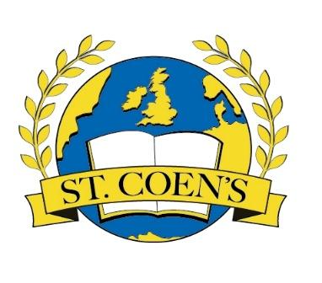
Introductory Statement
This PE plan for St. Coen’s N.S. was formulated in consultation with the teachers and members of the Board of Management.
Rationale
Physical Education provides children with learning opportunities through the medium of movement and contributes to their overall development by helping them to lead full, active and healthy lives. We aim to provide optimum learning opportunities for the children in our school by maximising active learning experiences and approaches which benefit each individual child.
Vision
Physical Education is distinguished from other curricular areas by its primary focus on the body and on physical experience and is an integral part of the educational process, without which the education of the child is incomplete. By implementing a diverse range of experiences that provide regular, challenging physical activity, the balanced and harmonious development and general well-being of every child can be fostered.
Through our physical education programme, our children can experience the joy of physical exertion and the satisfaction of achievement while developing skills and positive attitudes that enhance self-esteem. Physical education provides opportunities to develop desirable personal and social attributes: the concept of fair play, the acceptance of success and failure, and the ability to co-operate in group situations. These opportunities contribute to the understanding and promotion of a healthy life-style. Physical education, as an integral part of the total curriculum, provides vital opportunities for the physical, social, emotional and intellectual development of the children in our school. We aim to provide Physical Education opportunities which meet the physical needs of each child and their need for movement experiences, challenges and play.
We aim to develop a desire for daily physical activity in all of the children through encouraging constructive and active use of free time, so that children will be motivated towards participation in physical activities in adult life. To fulfil these needs, our Physical Education programme is built on the principles of variety and diversity. We aim to provide a wide variety of movement activities appropriate to the level of development of each individual child.
Aims:
We endorse the aims of the Primary School Curriculum for Physical Education;
- to promote the physical, social, emotional and intellectual development of the child
- to develop positive personal qualities
- to help in the acquisition of an appropriate range of movement skills in a variety of contexts
- to promote understanding and knowledge of the various aspects of movement
- to develop an appreciation of movement and the use of the body as an instrument of expression and creativity
- to promote enjoyment of, and positive attitudes towards, physical activity and its contribution to lifelong health-related fitness, thus preparing the child for the active and purposeful use of leisure time.
Broad objectives
The physical education curriculum should enable each child to:
- Social and personal development:
- experience enjoyment and achievement through movement
- interact and co-operate sensitively with others, regardless of cultural or social background or special needs
- develop qualities of self-esteem, self-awareness, confidence, initiative and leadership through movement
- develop an understanding of fair play and team spirit through participation and competition
- develop positive attitudes towards participation in movement activities
- experience adventure and challenge

- Physical and motor development:
- develop strength, speed, endurance and flexibility through engaging in a wide variety of activities
- develop agility, alertness, control, balance and co-ordination through movement
- develop personal competence in the athletic skills of running, jumping and throwing
- perform dances with confidence and competence, including simple folk and Irish dances
- develop personal competence in a range of gymnastic movements
- develop personal competence in the games skills of sending, receiving and travelling using a variety of equipment, and to apply these skills in games situations
- apply the skills needed to live and move with confidence in the environment

- Knowledge and understanding
- develop an understanding and general knowledge of movement activities and derive benefit as a participant and as a spectator
- develop an understanding of travel and weight-bearing as the basis of efficient body management and control, both on the floor and using apparatus
- experience and develop an understanding of the use of space, speed, effort, direction and level in the performance of actions
- develop an understanding of the appropriate basic rules, tactics and strategies of movement activities
- observe, discuss, analyse, interpret and enjoy the performance of movement
- gather, record and interpret information on achievement in movement activities
- be inventive, make decisions, solve problems and develop autonomy through movement activities
- participate in and develop a knowledge, understanding and appreciation of cultural activities through movement
- develop an appreciation of and respect for the environment through participation in activities outdoors

- Creative and aesthetic development
- use the body as a means of expression and communication, using a range and variety of stimuli
- create and perform simple dances
- create and play simple games
- maintain and enhance health-related fitness through vigorous physical activity that helps to promote a healthy lifestyle
- understand and practice good hygiene and posture
- appreciate the benefits of relaxation and cope with challenges

- Development of health-related fitness
- maintain and enhance health-related fitness through vigorous physical activity that helps to promote a healthy lifestyle
- understand and practice good hygiene and posture
- appreciate the benefits of relaxation and cope with challenges

- Development of safety
- adopt safe practices in all physical activities.

Curriculum Planning for Physical Education

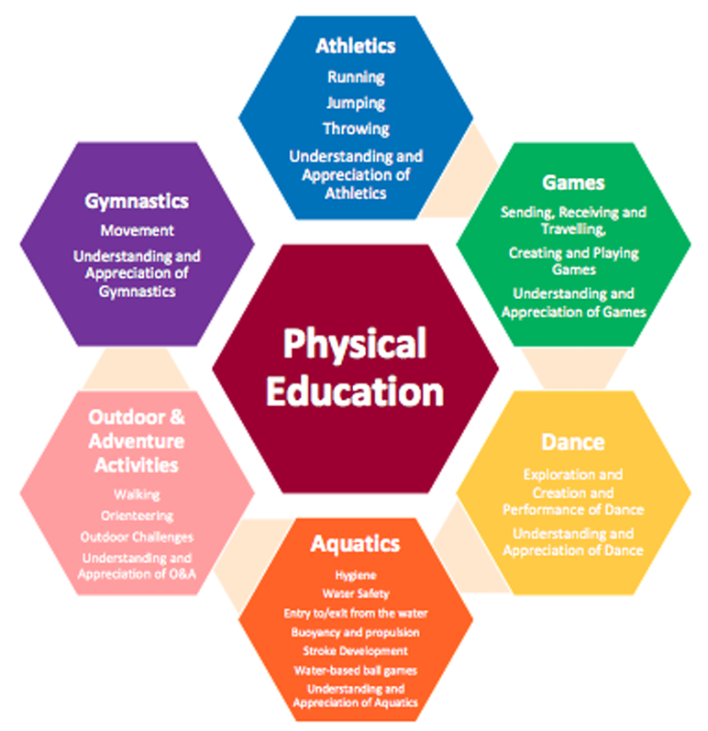

The PE curriculum is organised into the six strands shown above. These strands and strand units can be found on the following pages of the Physical Education Curriculum;
- Infant classes pg.16-23
- First and Second classes pg.24-34
- Third and Fourth classes pg.38-46
- Fifth and Sixth classes pg.48-59
Aquatics: pg.62-64 6

In planning for teaching PE, teachers will be guided by the PE Curriculum Teacher Guidelines and will also use the PDST Move Well, Move Often Physical Literacy Resource. Teachers may also use PE lesson plans prepared by the Primary School Sports Initiative- PSSI Lesson Plans.

Developing the Physically Literate pupil in Physical Education
We use the Move Well, Move Often resource to support the teaching of Physical Literacy in St.Coen’s N.S.
Physical literacy is the underlying goal of all physical activity. Physical literacy addresses the whole child and respects each pupil as an individual. The physically literate child can be described as having the motivation, confidence, movement competence, knowledge and understanding to value and take part in physical activity throughout their personal lifelong journey.
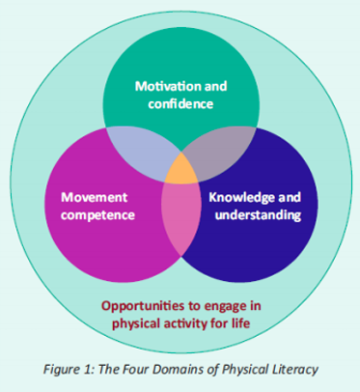
Physical literacy includes four essential and interconnected elements whose relative importance may change throughout life: Movement Competence, Motivation and Confidence, Knowledge and Understanding, and Opportunities to engage in physical activity for life. Physical Literacy gives pupils the tools they need to take part in physical activity and sport, both for healthy lifelong enjoyment and for sporting success. To become physically literate, pupils need to master fundamental movement skills (FMS) through a series of developmental stages. FMS are the basic building blocks of movement and are an essential part of everyday life and recreational activity. It is only when these skills are mastered that a child can go on to develop specialised movement skills, which will allow them to reach their potential in sports-specific endeavours.
Fundamental movement skills
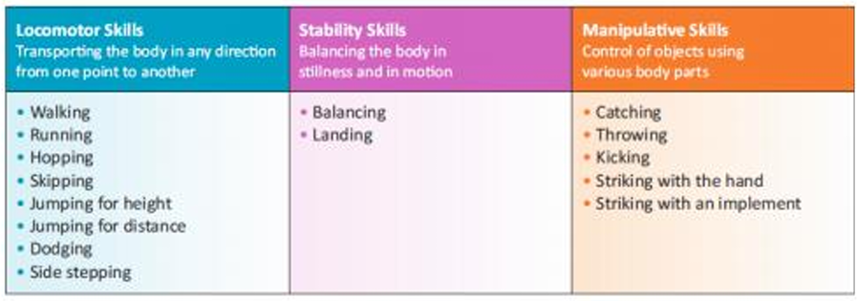

We recognise that it is important to teach a balanced range of locomotor, stability and manipulative skills across the strands during the year. Our focus is the development of fundamental movement skills within the strands of the PE Curriculum. Our whole school plan for PE reflects this approach. Teachers will utilise the following core resources to support planning for and teaching a broad and balanced programme of Physical Education:
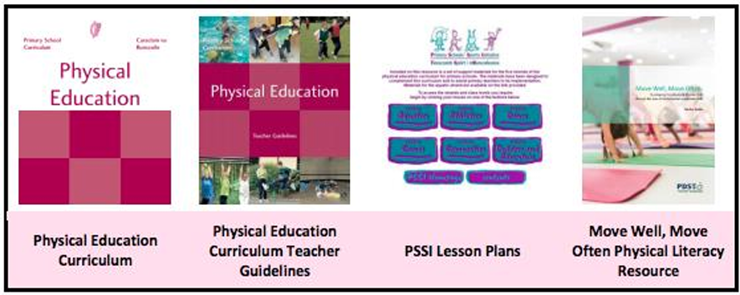
The role of the teacher is to:
- Help each child to develop a positive self-image and sense of fair play and cooperate with others.
- Ensure that the child experiences a variety of vigorous and challenging activities.
- Foster a stimulating and secure environment in which the child can be creative and imaginative.
- Link physical education activities with other curricular areas when appropriate.
- Evaluate the programme and assess the progress of each child.
- Provide information to parents, in line with school policy, about the class programme for physical education.
- Have due regard for safety by ensuring that each child adopts safe practices.
- Teachers will devise a balanced programme in line with this plan which meets the needs of each child in their class. Where possible, children will have experience the following five strands each year – Athletics, Dance, Gymnastics, Games, Outdoor and Adventure Activities. Aquatics will be provided for a six week block for 3rd to-6th Class in Coral Leisure Centre.
Continuity and Progression:
- Teachers will ensure there is continuity and progression from class to class by
- Utilising appropriate warm-up activities relative to each class level.
- Following the structure of the Whole School Plan.
- Recording the content covered at each level in each strand (Cúntas Míosúil).
Approaches and Methodologies:
Teachers may use a combination of the following approaches or methodologies;

Active learning:
Guided discovery/Enquiry Talk and discussion
Problem solving
Collaborative/Co-operative
Learning Using the environment Skills through content
Use of ICT Free exploration of materials
Learning through play
Direct teaching
Station teaching
Co-operative games
Grid based teaching (using small spaces at start of new learning)
Exploration of movement (gymnastics and dance)
TGFU – teaching games for understanding
Problem based learning Use of books, images and video as stimulus

Structure of a PE lesson
Introduction
- Begin by stating the intended learning outcome for the class. Ensure this outcome is linked to the FMS being addressed.
- Introduce a maximum of two teaching points for the FMS per lesson.
- Revise prior learning in relation to the skill, where necessary, in a quick and concise manner.
Warm Up:
Link this activity to the FMS being addressed where possible.
Main Content:
Deliver the curricular content of the lesson in accordance with your PE plan incorporating two teaching points of FMS where appropriate. The FMS being addressed should not be the sole focus of the PE class.
Development
Consider using a teaching approach such as Whole-Part-Whole (other approaches are presented in the Physical Education Teacher Guidelines):
After introducing the teaching points set up a game or relevant activity (whole). Pause the activity and teach one or two of the key components of the FMS in isolation (part). Allow me for pupil reflection. Then restart the game or activity to practise the skill in an authentic setting (whole).
Note: Opportunities may arise for the teacher to support individual pupils through effective feedback and questioning.
Conclusion
- Summarise learning.
- Consider incorporating effective questioning or pupil self-reflection.
- This may also be a useful me to give homework or set a target for the next PE class.
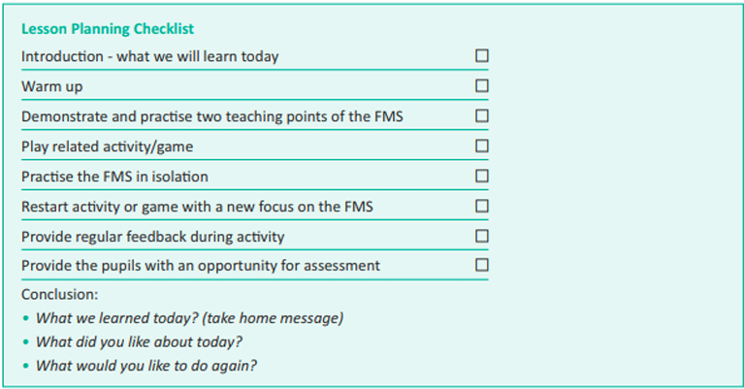

Multi-class teaching (If ever needed)
Individual and partner work can be facilitated through good communication, good planning and good organisation from the PE teacher. For children of different age groups and who are at different stages of development, having older or more able peers around will assist them through their zone of proximal development. The play area and available space during PE classes is either divided up and used separately, or shared by the multiple groups who are working together in developing new skills.
Follow up activities to a basic lesson include small sided games. These games are designed to practise the skill learned during the lesson but in a more fun and enjoyable way. The main focus is on enjoyment and fun while developing the acquired skill. Another follow up activity is conditioned games, where teams compete against each other in a controlled and non-competitive environment.
When groups are assembled during an activity, they consist of mixed age and mixed ability. This allows the more able and confident children to share ideas and knowledge with the less confident and able children. The less able children can even be chosen to be a leader or captain of a group to help them be more open to and feel more positive about learning. In essence, the children are teaching each other through the guidance of the teacher.
Children with Different Needs:
In St. Coen’s N.S., we recognise that physical education is important in the curriculum for students with Special Educational Needs and disabilities. Pupils with special educational needs or disabilities depend on teachers to manage their learning and to provide support. Inclusive PE ensures that all pupils experience a sense of belonging during the lesson. This includes feeling respected, valued for who you are, and feeling a level of supportive energy and commitment from others. It is important to create and encourage a positive environment and to provide pupils with opportunities to enjoy physical activity with others, so that they will, in the future, approach activity as a means of socialisation and integration in the community.
Many children with SEN experience difficulty with basic coordination, balance, left and right orientation, rhythm, and spatial and body awareness. These skills can be addressed and improved through physical education. As it is a practical subject, it is particularly suited to the learning styles of many students with general learning disabilities. Students who experience difficulties and frustration in academic areas of their school life can enjoy and acquire personal achievement and satisfaction in the physical education curriculum. Physical education is a student-centered curriculum that challenges each student at his/her personal level. It is also a very sociable subject involving a high level of appreciation and acceptance of others.
Physical education can enable students with general learning disabilities to acquire and enjoy many physical skills during their school life, and so widen the possibilities for recreation and socialization in their adult lives. It provides the student with an avenue to enjoy life and social interaction. All children will be encouraged to participate in all PE activities through the use of co-operative fun activities. We will provide encouragement and acknowledge good effort wherever possible. Our main aim is to set activities close to each child’s ability level but at the same time challenging them to improve their performance. Reasonable targets will be set for all children at individual, pair and small group levels. Teachers will endeavour to support and ensure the participation of children with Special Educational Needs and disabilities through an inclusive approach to planning for PE.
In order to make our PE curriculum inclusive and accessible, the following ideas may be considered when planning for inclusion of students with disabilities and Special Educational Needs:
- Skills, concepts and activities will need to be redefined and broken down into progressive stages to meet the varying abilities of these students.
- Learning expectations should be reasonable in meeting the balance between familiar and unfamiliar skills and activities.
- Realistic targets should be set, appropriate activities and equipment should be chosen, and sufficient time should be given to bridge the gap between applying familiar skills and learning and applying new skills and concepts.
- Positive reinforcement should be given frequently, the ability of the students should be emphasised, and appropriate activities should be provided in order to improve the self-esteem and confidence of these pupils.
The following support materials will assist teachers in planning for children with SEN and disabilities:
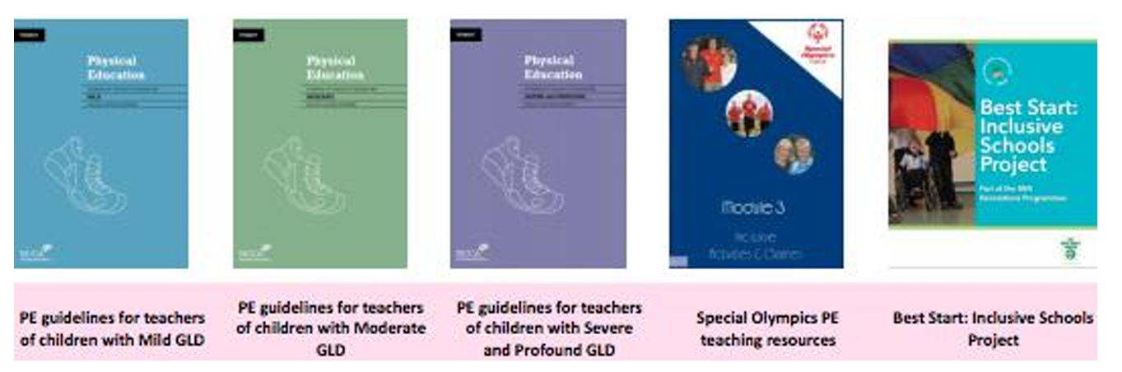
All pupils exhibit a wide range of abilities in the area of PE. Some may be talented, some may be gifted, while others show significant needs and require guidance through a progressive and systematic approach to their participation and learning. In planning for teaching this subject area, it is important to keep in mind the following key issues and learning difficulties that pupils may have.

Differentiation:
Differentiation will coincide with the needs of the students, as determined by the teacher. The following table highlights potential areas of difficulty for students with mild general learning disabilities, as seen on page 19, NCCA Draft Guidelines, Book 3 – for Teachers of Students with Mild General Learning Disabilities.
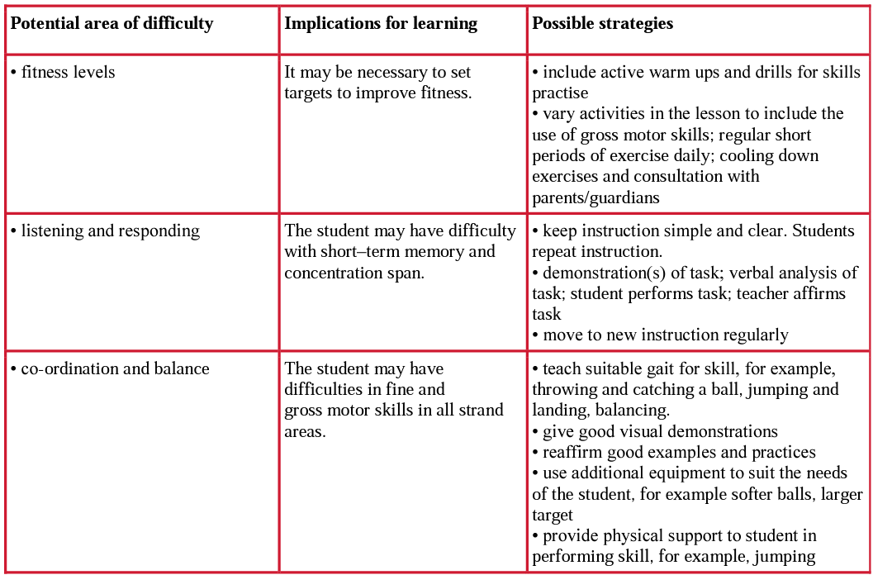
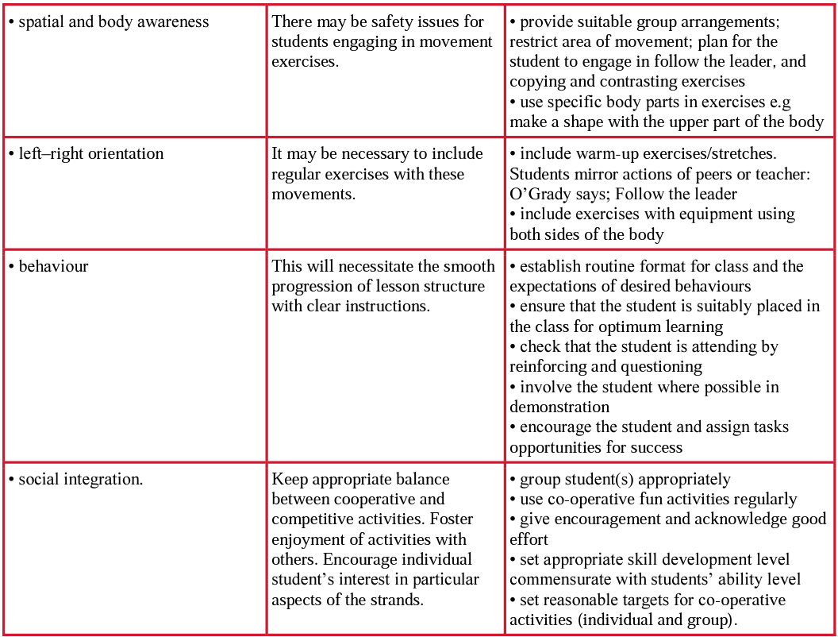
Exceptionally Able Children
Children with exceptional ability or talent for PE will be encouraged and supported by acknowledging their talents and creating additional challenges for these children in the strands of the PE curriculum they excel in. These challenges will be based on the activity being pursued by the rest of the class. In addition, the children will be encouraged to maximise their talent by forging links with local clubs (if links have not been established already) so the child(ren) can progress their talent to a higher level. The children with exceptional ability will, on occasion, be encouraged to assist their classmates in achieving proficiency in the activities they are undertaking.
We will refer to the PE checklist in the NCCA Draft Guidelines for Exceptionally Able Students to identify children who have a special ability or talent for PE.
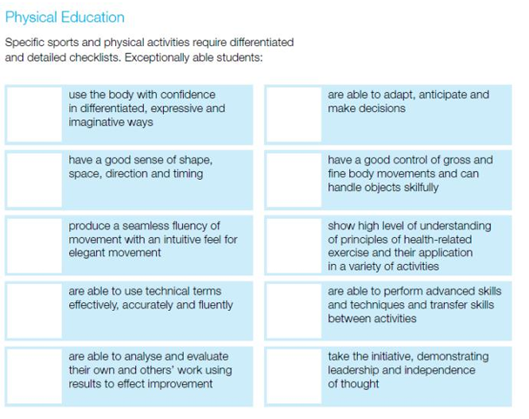

Assessment and Record Keeping :
The teachers in the school constantly assess in the PE lessons delivered as we identify progress and difficulties. We will assess;
- Willingness to participate in activities
- Readiness to engage with a certain activity
- The level of competence of a child in carrying out an activity/FMS
- Interest in and attitude towards an activity
- Willingness to cooperate in individual, pair and group activities
Our assessment tools are:
- Teacher observation
- Teacher-designed tasks
- PE/Well-being copies to possibly be introduced (Senior End).
Assessment is used to provide information on individual children, assist the teacher in planning a programme and facilitates communication with other teachers, parents and other professionals.
- Assessment for learning to provide feedback to children, improve learning and inform practice
- Assessment of learning which helps to identify the milestones children reach and the progress they make to report to parents, other teachers and the children themselves.
- Assessment as learning involves teaching the children how to self-assess and peer assess.
The assessment criteria used for each activity forms part of class and school planning. The school may use a PE copy in the senior end to guide Self-Assessment. Teachers will refer to the PDST teacher checklists, peer observation checklist and Individual Assessment Profiles from the Move Well Move Often website and resource pack.
Assessment information is shared with parents at Parent Teacher meetings and in end-of-year school reports. The school will communicate through Class Dojo as a home school link as well as home activities and PE homework at certain times of the year.

Equality of Participation and Access
- We will endeavour to ensure that all children from infants to sixth class will partake in all six strands of the curriculum during their primary education.
- Aquatics will be provided for 3rd-6th class.
- We will provide equal access for all children to physical education equipment and facilities and the use of the playground during breaks will be incorporated as an integral part of the school’s programme.
- As a staff we will help children to build positive attitudes towards all activities.
- All children are encouraged to participate in school team sports. Selection of school teams are decided by the teachers or the Sports Team. While it is hoped that all children would get to participate, the management team will consider the following when selecting the team. This includes participation and interest shown at after schools sports, target pupils, level of ability and previous performances.
- St. Coen’s N.S. will endeavour to involve some of our target pupils in After School Sports Clubs and sporting outings.
Various staff members will provide after school training in a variety of sports- athletics, badminton and games.
Competitions such as the Wicklow Invitational Athletics , Cuman na mBunscoil, Badminton and FAI will be entered every year. We hope to broaden the number of sports events we participate in over the next two years.
Linkage and Integration
Many of the broad objectives of PE, such as the development of self-esteem, confidence, cooperation and spatial awareness, are shared with other curricular subjects. Within PE, it is through learning opportunities provided in the various aspects of movement that these objectives can be achieved. The transfer and reinforcement of learning from other areas of the curriculum can be achieved when PE is integrated with other subjects. This approach can be particularly effective in meeting the needs of pupils with individual and varied learning styles, and enables pupils to appreciate how physical literacy is an integral part of all our lives.
- Linkage can take place within the physical education curriculum, because many activities transcend strands and are of benefit to the child irrespective of the strands or subjects being covered. Within the content of the curriculum, footnotes below the strand units suggest where linkage and integration might take place in the PE class.
- Theme based activities will be used to support integration.
- Our Active School Walkway has great opportunities for linkage on the signs.
Language
The effective use of questioning from the teacher will develop the vocabulary associated with physical education. Allowing the children to analyse and describe their own performance will allow them understand and appreciate their learning in physical education.

Organisational Planning
In this school all classes will timetable two 30 minute physical education lessons per week. The Whole School Plan below will see all classes develop a strand over a month with an emphasis on a Fundamental Movement Skill during that period. There will be a Game of the Month. Fundamental movement skills will be covered over a two year period and this plan offers a balanced approach to the teaching of all the fundamental movement skills necessary to a child’s development.
Individual Teachers’ Planning and Reporting
The whole school plan and the curriculum documents for PE will lay out the structure and format that teachers will follow in addition to the aims and objectives of the primary school curriculum. While these documents are vital for planning, it is important that teachers do not rely on them exclusively as it is necessary to adapt the PE plan to your own class level and experience. It is vital that all teachers plan individually while at the same time ensuring that their class plans co-ordinate and feed into the overall school plan.
Teachers will plan based on the strands and the specific Fundamental Movement Skill as outlined on the yearly timetable. Teachers will select one/two teaching points each week to encourage fundamental movement skill proficiency based on the class level. External providers will be made aware of the FMS to enhance the children’s learning.
The Cuntas Miosúil will be very relevant in reviewing and developing the school plan for the following years. Once the individual Cuntas Miosúil have been evaluated it should be obvious to the staff which elements of the curriculum were being implemented.

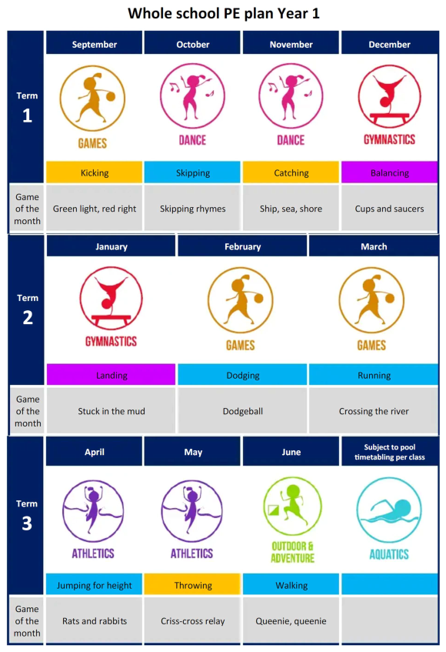
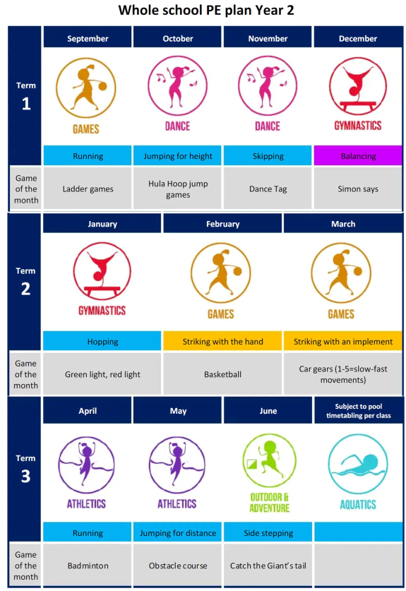
Organisational Tips for PE
Establish clear rules, routines and expectations for PE class.

Establish a clear signal for drawing the pupils into a group for the purpose of direct instruction, and use this signal consistently.
Structure lessons that foster success. Select inclusive activities that meet the needs of all pupils.
Provide consistent encouragement, effective feedback and reinforcement.
Take care to ensure maximum me for participation in physical activity within the lesson.
Maximise participation by avoiding exclusion and knockout games.
Avoid activities with long wait times. Consider setting up two of the same activity if space allows.
Lessons should allow progression from initial work undertaken individually to work with a partner and work as a member of a small group.
Provide opportunities for pupils to work in groups to enhance cooperation in preparation for the development of team play in games situations.
Strike a balance between competitive and cooperative activities. The focus should be on participation.
Small sided games and mini versions of games with modified rules are suitable for PE lessons.
Encourage pupils to create their own games and modified activities.
Consider availability of space, resources and support personnel when planning for grouping of pupils. Discuss opportunities to practise what is learned in PE beyond the classroom.
Invite pupils that can exhibit good technique to showcase the skill for the rest of the class.
Provide opportunities for the pupils to begin practising immediately after viewing a demonstration.

Code of Ethics
(Refer to school’s Child Protection Policy based on the Department of Education and Science guidelines accompanying the ‘Children First’ guidelines).
- If coaches from a local or a national sporting organisation are invited into the school to work with the children as part of their PE class, they will be used to support the class teacher in the implementation of some of the PE curriculum strands in the school. They will not replace the class teacher and ultimate responsibility for the class lies with the class teacher. The class teacher will in turn support the coach on certain occasions when this will lead to maximum benefit for the children in the class.
- Any coaches working in the school context should undergo Garda Vetting and will be expected to adhere to the Code of Ethics of Irish Sport, produced by the Irish Sports Council. ‘Adults interacting with children in sport (referred to as Sports Leaders in this Code) are in a position of trust and influence. They should always ensure that they treat children with integrity and respect and that the self-esteem of children is enhanced. All adult actions in sport should be guided by what is best for the child and carried out in the context of respectful and open relationships. Verbal, physical, emotional or sexual abuse of any kind or threat of such abuse is totally unacceptable within sport, as in society in general.
- If there is a suspected case of child abuse in the class (even if it becomes apparent in the context of a PE class), all teachers will adhere to the Department of Education and Science Child Protection Guidelines to be used with the ‘Children First Guidelines’ (2011) produced for all personnel working with children.
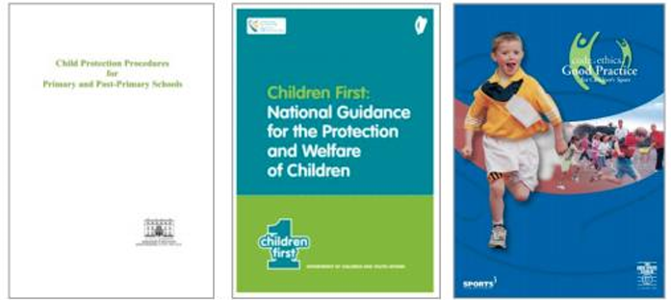

PE Equipment (Refer to pp. 104-105 Teacher Guidelines)
- Our school has a detailed inventory of equipment and resources available for PE.
- The equipment is stored in our PE store room in the school. Each teacher has the responsibility to ensure that all equipment is returned to the room after each lesson. The storeroom is checked regularly by the PE Post Holder, 6th Class Playground Leaders and the Active School Committee.
- In order to ensure a PE rich environment, the school will have a dedicated noticeboard in the PE Hall. FMS posters will be displayed , different sporting achievements and photographs.
- Resources available to teachers can be seen in the table below;
Beanbags | cones | softballs
GAA balls | Big basketballs | Small basketballs
Rugby balls | Skipping ropes | Parachute
Futsal kit | Hula hoops | Uni-hoc kit
2 crash mats | 4 mats | Tennis rackets & balls
4 benches | Yard games | Ladders
Badminton kit & net | Tag rugby kit | Large goal
rebounder | Rounders kit | CD player
Large speaker | Yoga matts | Gymnastics horse
hurleys | bibs | 2 GAA jersey kits
Athletics singlets | 2 tug of war ropes | pumps
Online resource for Dance: History Through Dance | Fit4Schools

ICT (Refer to p. 101 Teacher Guidelines)
In our school, we use Aladdin and Class Dojo to communicate with parents. Class Dojo is a digital portfolio and a communication tool for our students and parents where we share our work, events and good news between school and home. Class teachers may choose to create an digital portfolio for PE, where they can share, video, pictures and information with parents and children. These may include and information on a fundamental movement skill, teaching point or a video detailing a child’s progress and development within a particular skill.

Health and Safety Considerations (Refer to the school’s Health and Safety Policy)
Issues identified as being health and safety issues in a PE context include warm-up at the start of all physical activity, practising in confined spaces, use of equipment, accidents, supervision, activities involving the whole school yard, procedures for dealing with accidents …etc It is important to acknowledge from the beginning that while the following procedures will eliminate unnecessary hazards they cannot remove all risks due to the physical nature of the subject. When engaging children in PE all members of staff will ensure that the following safety aspects will be taken into consideration.
- Ensure shoelaces are tied, clothing is tucked in, and all jewellery is removed.
- Ensure the playing area is free of obstructions, trip hazards and dangerous objects.
- Ensure the playing area used is an adequate distance from walls and other fixed furniture, allowing a safety zone for pupils to slow down and stop when necessary.
- When using pair or group work, ensure there is adequate space between groups to prevent collisions.
- Encourage pupils to keep their eyes open and head up when moving in a condensed playing area.
- Remind pupils about safe, respectful tagging. Ensure that pupils do not grab or push each other, and that they use so hands to gently tag their opponents, on the back of the torso between the hip and the shoulder. Explain clearly to pupils the correct way to tag safely.
- Many fundamental movement skills, particularly locomotor skills, can be strenuous in nature. Allow pupils the opportunity to rest or stretch at regular intervals during activities.
- For safety reasons encourage the concept of spatial awareness regularly. Invite pupils to imagine that they are inside a bubble, and if they touch anyone else, their bubble will burst
- When using an implement, ensure pupils position themselves a safe distance back from the striker. Use cones/spot markers to identify safe zones and striking zones when necessary.
- The safety statement within the school plan should contain procedures to be adopted should accidents occur in the physical education lesson.

Staff Development
The responsibility of researching new methodologies should lie with each individual teacher, however, sharing ideas and knowledge within the staff should be encouraged. Demonstrations and opportunities to try out new equipment should be carried out by the school’s PE teachers. Available PE courses should be monitored and teachers made aware of these courses. Encouragement should be displayed from all teachers in regards to attending such courses. Teachers that do attend these courses, have the responsibility of sharing the expertise acquired with fellow staff members. This will help strengthen the school’s pedagogical approach in relation to physical education. Such ways of sharing information and knowledge should include emails, information on the staff-room notice board and whole school staff meetings.
Time is allocated at each staff meeting to discuss all matters relating to physical education. Here teachers can share ideas, raise awareness to any issues, and announce dates of upcoming events and courses.
Active Schools Week:
St Coen’s N.S. will facilitate an Active School Week whereby the discretionary curriculum time for the period in question is used to promote physical activity for all children in the school encompassing as many of the strands of the PE curriculum as possible. This will take place in June. This is due to better weather conditions for outdoor activities. In addition to PE we prioritise physical activity throughout the day during Active Schools Week.
After School Activities:
A variety of after school training and activities are organised in the school. The list of after school activities are as follows with more to be added; athletics, badminton, Games, soccer and many others throughout the year. These will take place at various times throughout the school year. During this time the children take part in child led activities such as games and free play. The children also get time to practise skills previously learned during PE lessons .
These activities will adhere to the general principles of the Physical Education Curriculum of the school as follows:
- The importance of enjoyment and play
- Maximum participation by all children
- The development of skills and understanding
- A balance between competitive and non-competitive activities
- A balance between contact and non-contact activities
- Providing opportunities for achievement for each child to enter competitions.

Parental Involvement
(Refer to Primary School Curriculum, Your child’s learning, Guidelines for Parents)
We will ask all parents to support their children to participate in all strands of the PE curriculum. Parent’s will be informed on the FMS that the class are focusing on. Parents will be encouraged to come and spectate at certain times.

Community Links:
We are very much aware of the school’s role in the community and we are also conscious of the fact that the expertise of people in the community is an invaluable resource to any school. We link with the community whenever possible.
Success Criteria
We will know that the plan is being implemented as the teachers’ plans will reflect what is laid out in this whole school plan. We will be able to see the schedule of games set out in the monthly schedule being implemented in PE sessions. Teachers will be able to plan more easily as they will know what PE games and skills are to be implemented during each month. As this plan is a new plan we will wait for it to be implemented and then answer the following points at the next review.
- Has the plan achieved its aims?
- What are the indicators? (Refer to Aims)
- Means of assessing the outcomes of the plan include:
- Teacher/parent/community feedback
- Children’s feedback regarding the activity level, enjoyment and skill development of the classes.
- Inspectors’ suggestions/report
- Second level feedback
- Has the plan promoted the key considerations when implementing a programme of Physical Education?
- Has the plan promoted:
  - the importance of enjoyment and play
  - maximum participation by all children
  - the development of skills and understanding
  - a balance between competitive and non-competitive activities
  - a balance between contact and non-contact activities
  - provided opportunities for achievement for each child
Review
The PE Whole School Plan will be reviewed in two years time (June 2025) by staff. PE will be discussed at each staff meeting. At the staff meeting in June teachers will be asked for feedback on PE for that academic year.
Inspectorate Ratification and Communication
The Board of Management ratified this policy on the 6th October 2023.

Signed :

